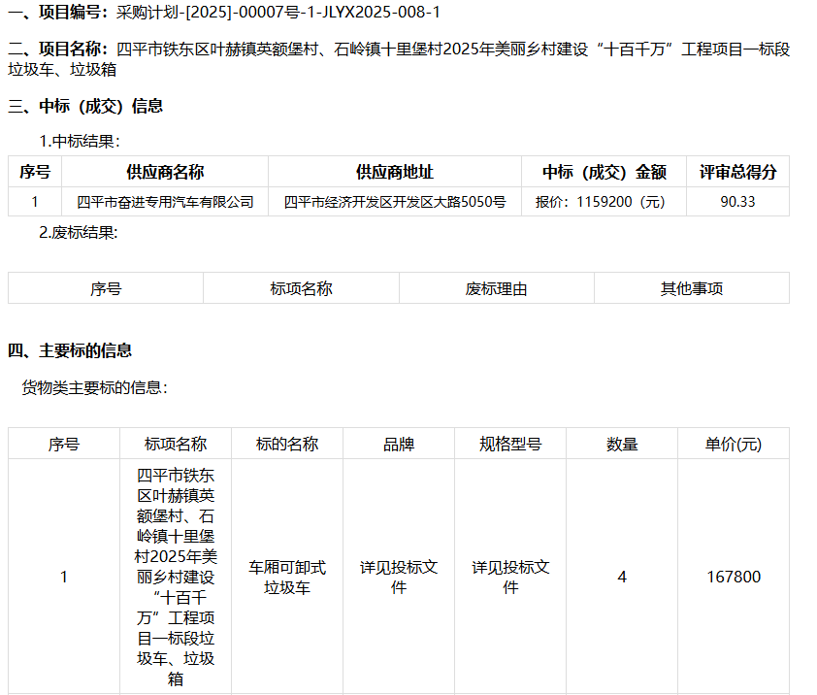公示链接http://www.ccgp-jilin.gov.cn/site/detail?categoryCode=ZcyAnnouncement&parentId=550068&articleId=6kDU3yl8v4gyXxoPS765pw==&utm=site.site-PC-39286.1045-pc-wsg-mainSearchPage-front.4.b10e231063cb11f0961a51bfa789e72a

